Nic Brand
CSCI-C 435
ULTIMA 2.0 – Phase 2 (IPC)
Testing Documentation
How I tested our program: I added functionality to manually send and receive messages between tasks. We can also view the mailbox count and log. It allows us to verify that it is working correctly as the program progresses.
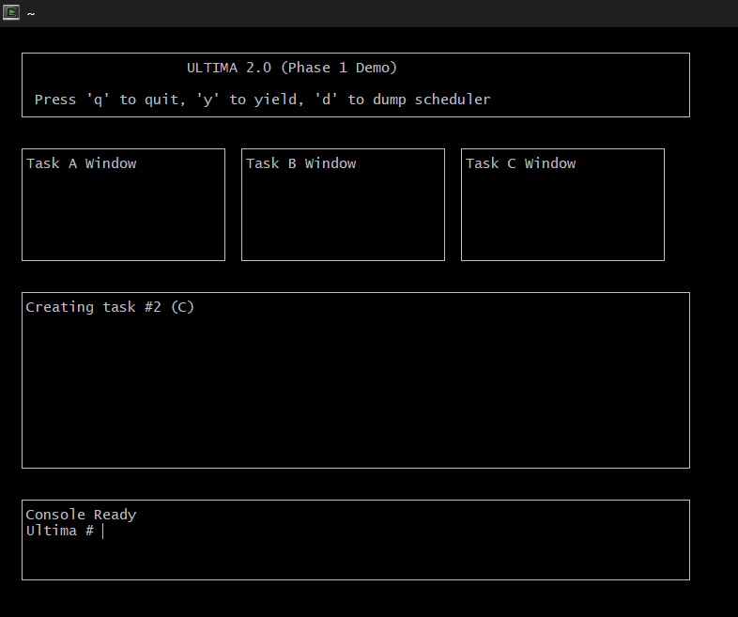
Test 1: At program startup, mailboxes are empty. No messages exist because no IPC operations have been performed.

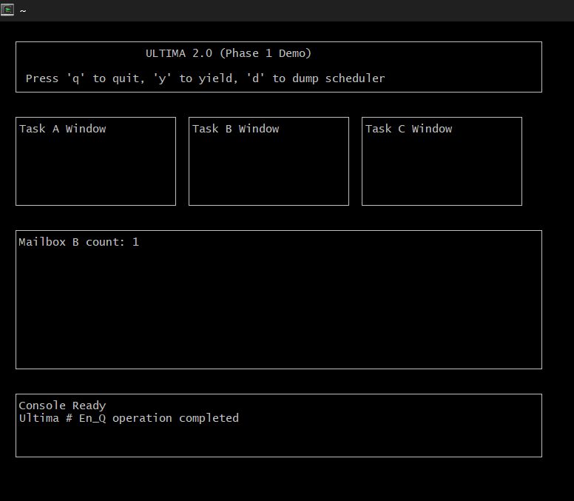
Test 2: Sent first message from A to B. Mailbox B is now 1, confirming it is working successfully.

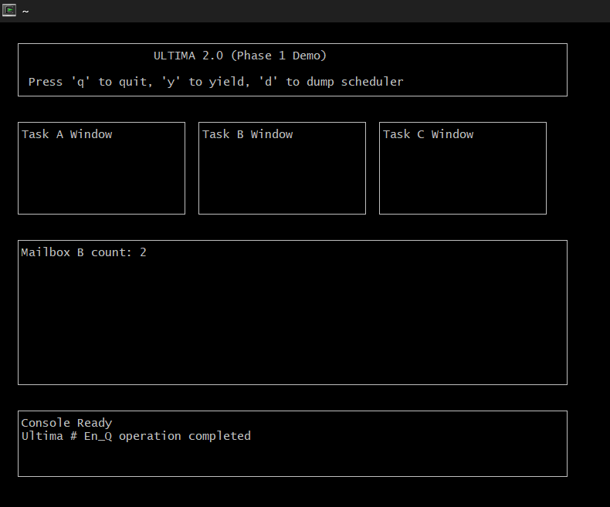
Test 3: Task C sent message to B successfully, proven by the count being 2. Multiple tasks can send messages to the same mailbox.
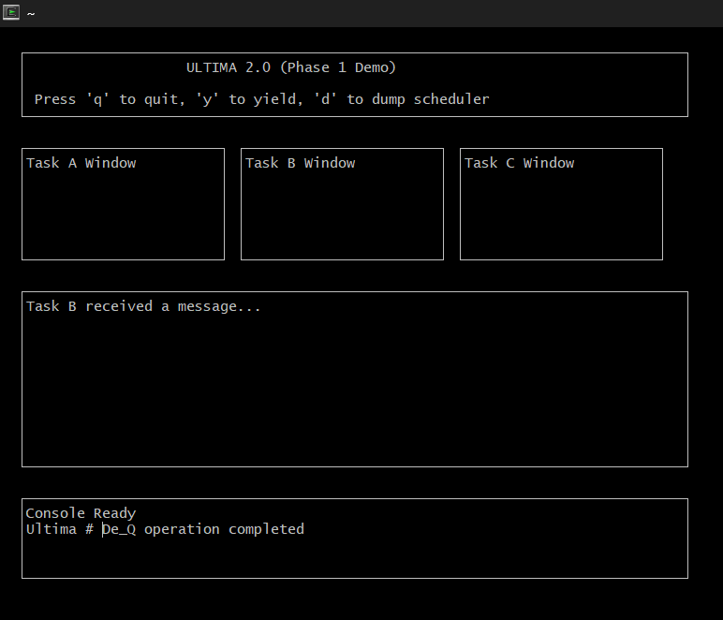Test 4: Task B receives one message. The mailbox count is updated to 1.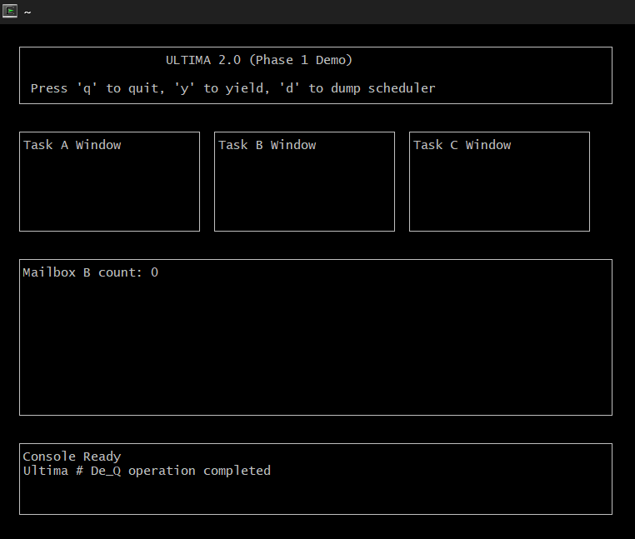
Test 5: Task B receives second message, proven by the fact that mailbox count is now 0.

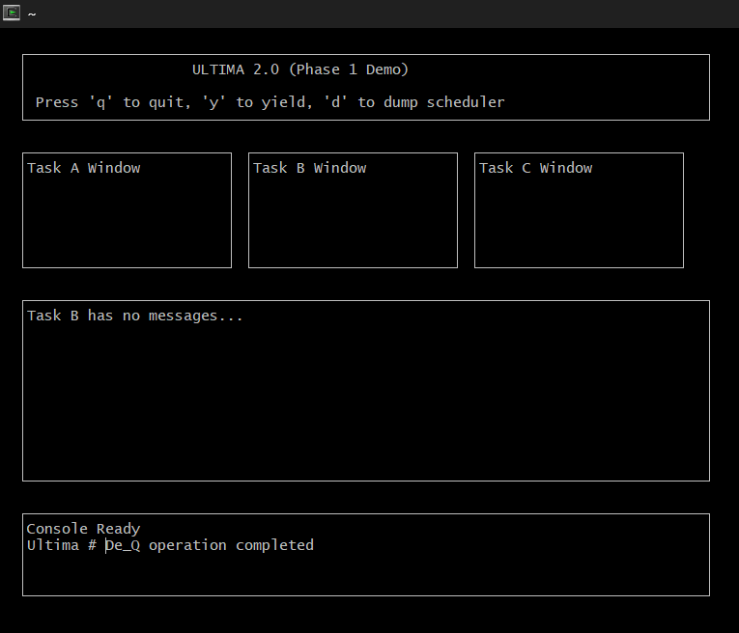
Test 6: If we try to receive messages with nothing available, we get the “Task B has no messages…” error.

Conclusion: The screenshots and explanations above prove that the IPC system is working as it should be. Messages are sent, received, stored, and removed correctly. It also displays a unique message when the user tries to receive a nonexistent message.

